14.46: a) See problem 14.45; the net force is 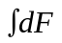 from where 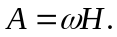 b) The torque on a strip of vertical thickness 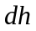 about the bottom is 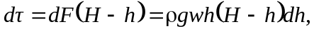 and integrating from 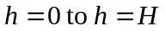 gives 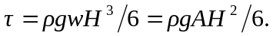 c) The force depends on the width and the square of the depth, and the torque about the bottom depends on the width and the cube of the depth; the surface area of the lake does not affect either result (for a given width).

